# Name - Aman Maurya

# Roll No. - 223CS3153

# Course - M. Tech (Year-I)

# Branch - CSE (Software Engineering)

# Assignment - (2) Selenium RC

1. Economic times

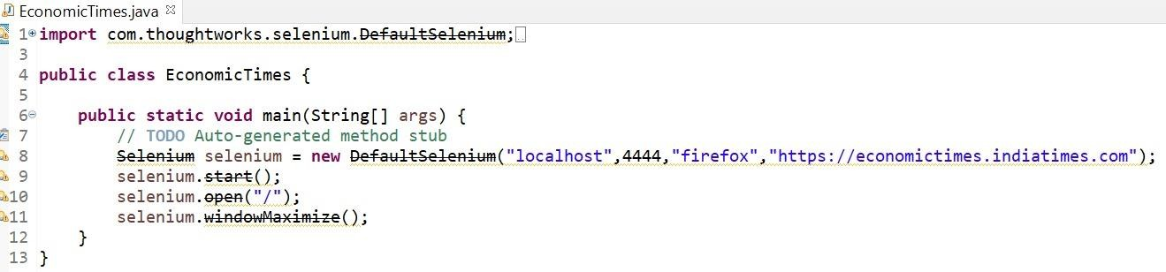

1. Irctc

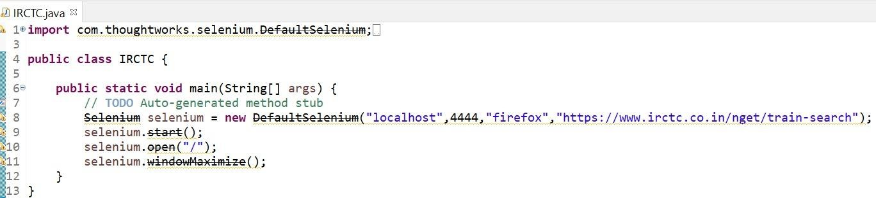

1. Jio

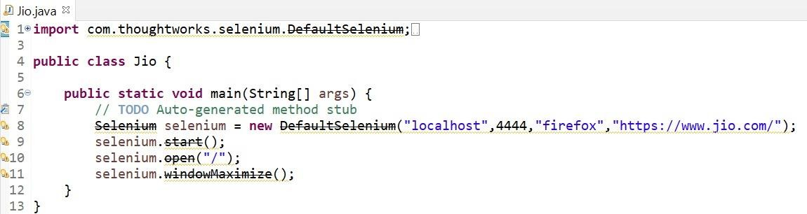

1. Mygov

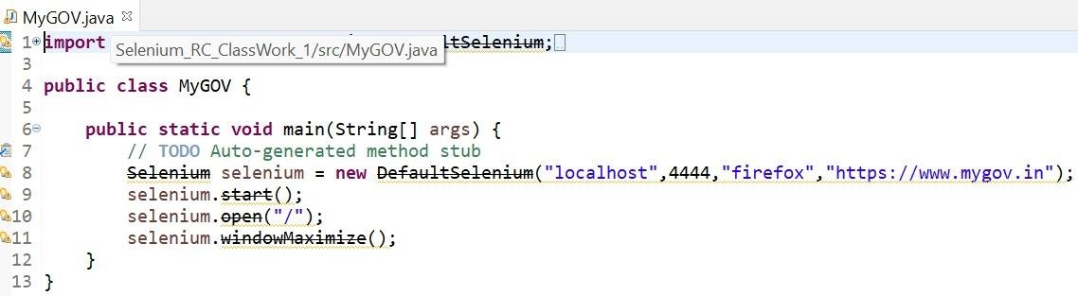

1. Onefootball

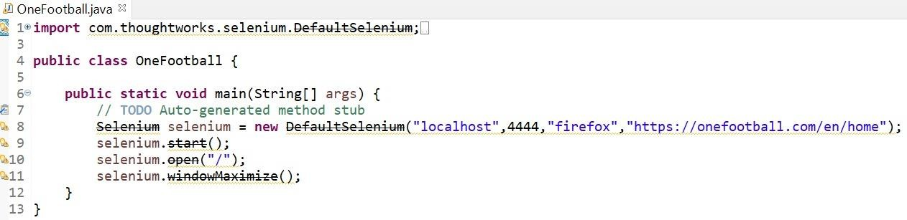

1. Flipkart

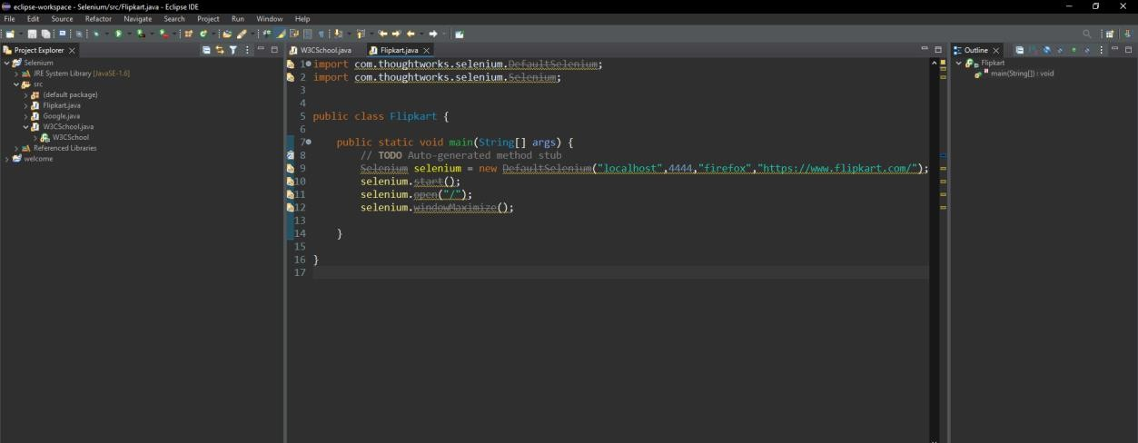

1. Google

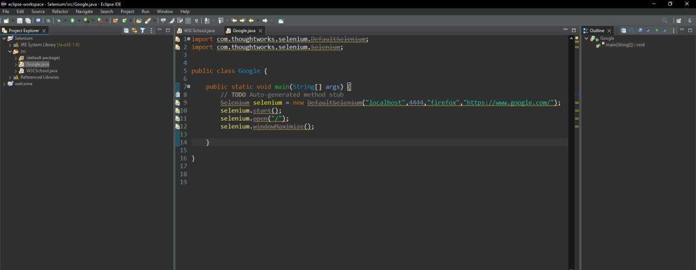

1. Intel

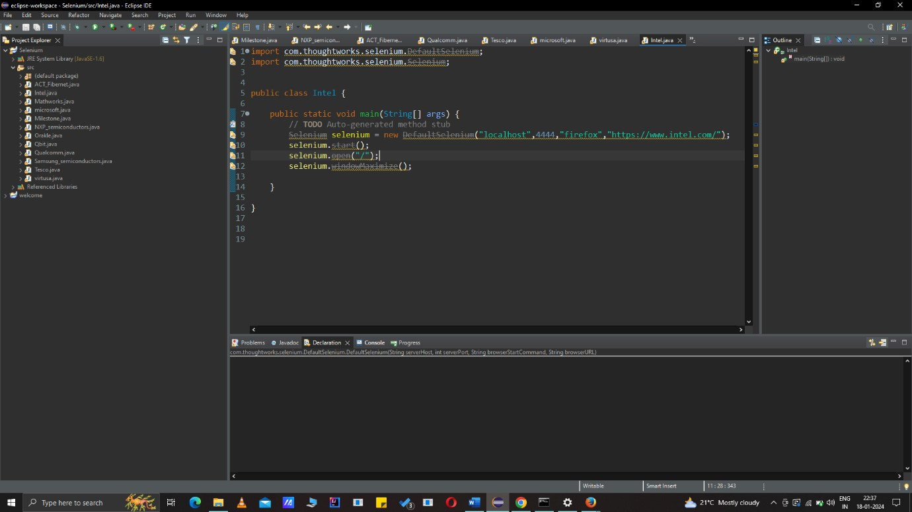

1. Linkedin

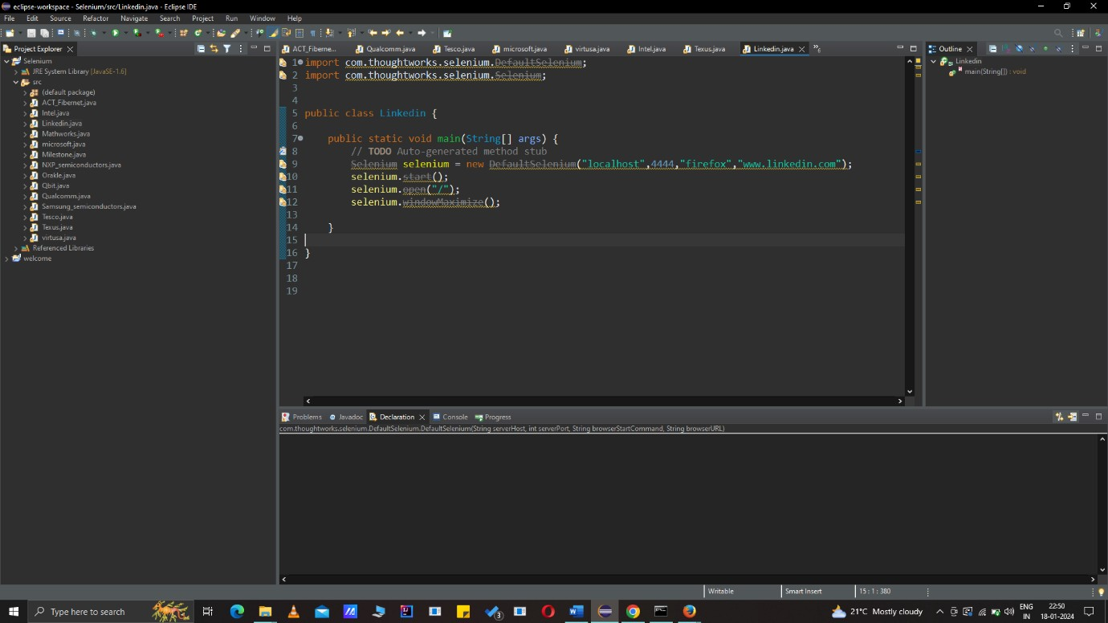

1. Microsoft

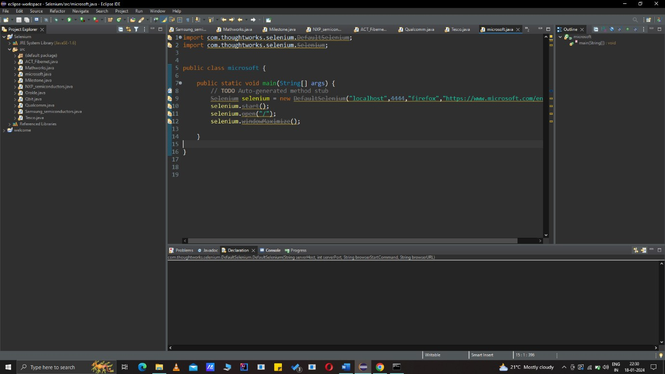

1. Qualcomm

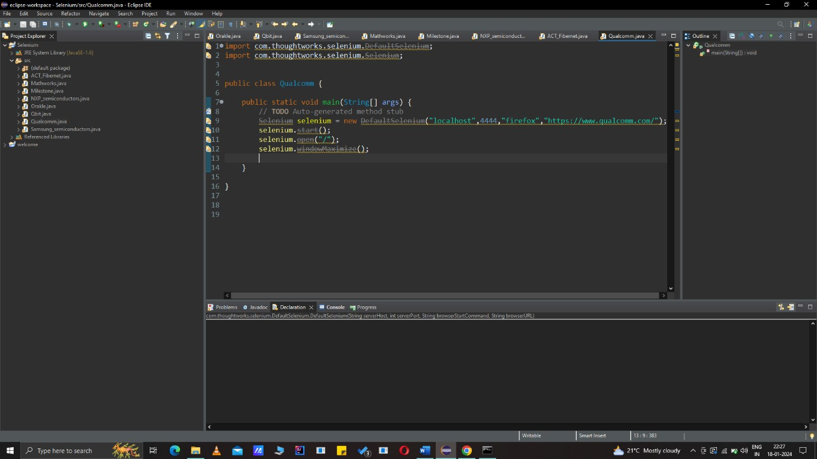

1. Tesco

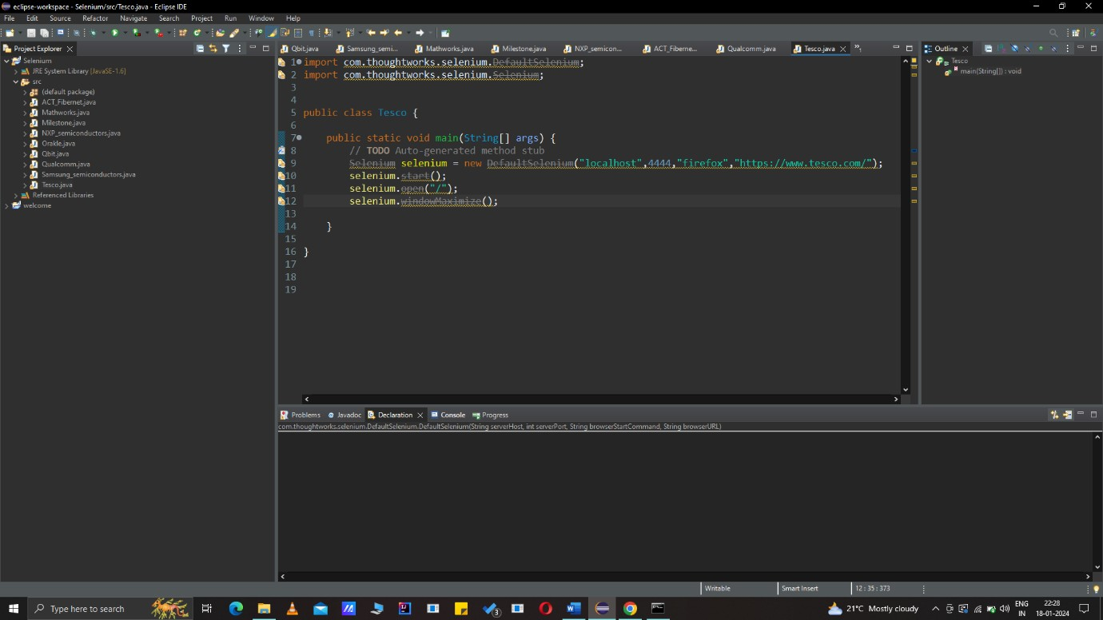

1. Texus

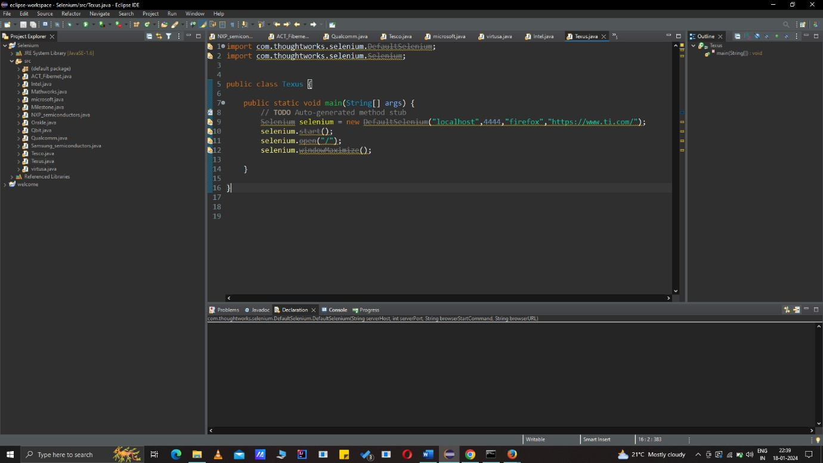

1. Virtusa

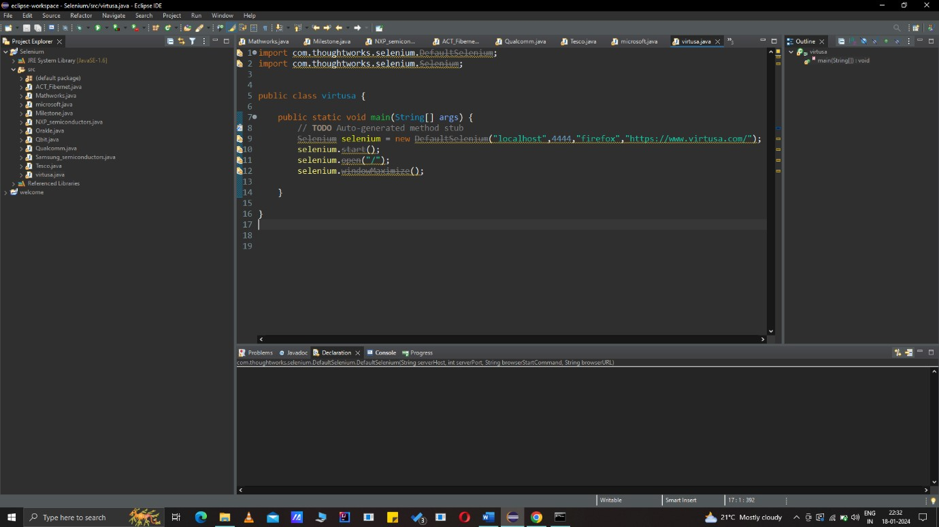

1. Wilipedia

